Summary:

IVs:

* Coop/comp
* Sentence type (PIC)
* Electrode or electrode region

DVs:

* % correct
* mean amplitude in N400 window to target window
  + expected P>C>I
  + expected: for C, coop<comp

Results:

Accuracy

* no effect of trialtype (comp/coop) (F(2,20) = 2.192, p = .138)
* marginally significant interaction between trialtype and group (PIC) (*F*(2,20) = 2.603; *p* = 0.099, *η2* = 0.180)
  + Info for graphing but I don’t have to report it. Mcomp = 0.906, SEMcoop = 0.018; Mcoop = 0.926, SEMcoop = 0.018; Mp = 0.931, SEMp = 0.013; MI = 0.886, SEMI = 0.017; MC = 0.931, SEMC = 0.025)

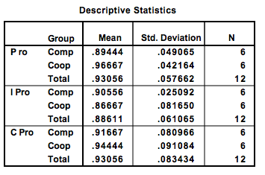

* + PxComp SEM = 0.02
  + so treat it as significant and graph it

P600 mean amplitude

* Main effect of trialType (*F*(2,20) = 11.592); *p* < .001; *η2* = 0.537; *MP* = 1.896, *SDP* = 1.501; *MI* = 3.783, *SDP* = 2.203; *MC* = 2.367, *SDC* = 1.581)
* Interaction of Trialtype \* Group (*F*(2,20) = 3.564; *p* = 0.047; *η2* = 0.263)
  + Info for graphing: 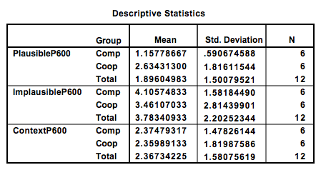

Survey Results

* Mann Whitney test🡪 participants perceived the jenga game to be competitive/cooperative as they were supposed to (*MdnComp* = 2.5, *MdnCoop* = 10 *, U* = 32 *, p* = 0.026)